CSC 9010-002

Python installation

Yiran Yu

2018/9/10

1. Python –version

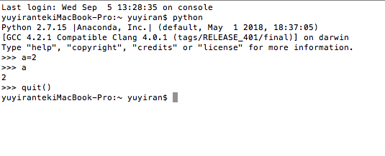

2. Jupyter tests pages done in the in class notes including the matplotlib

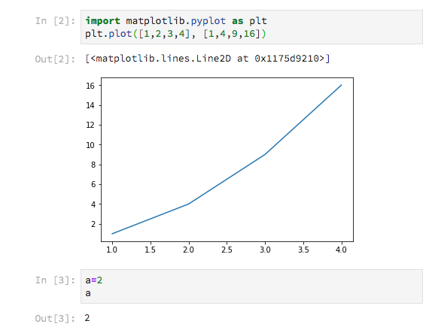

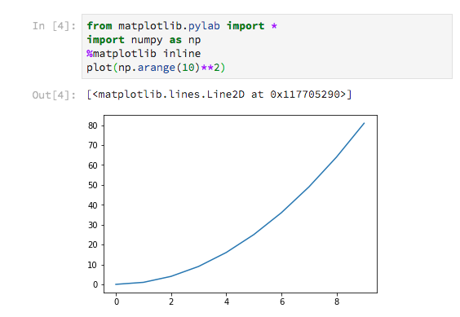

3. Spyder test

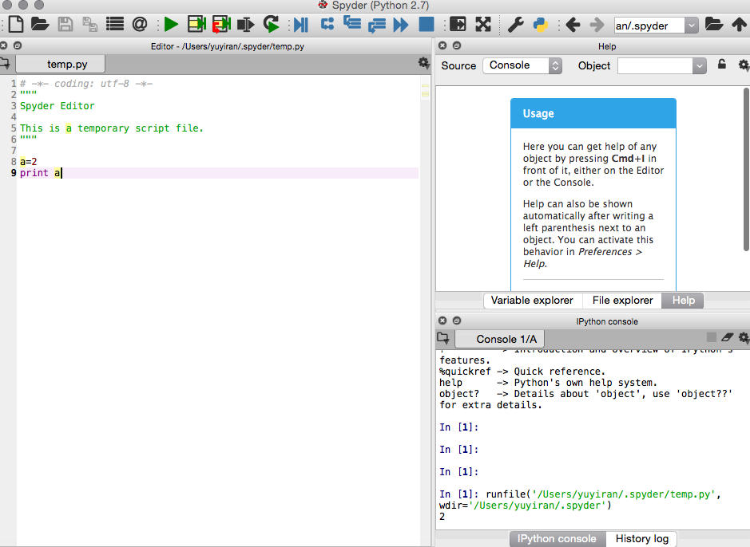

4. Generate the first 10 Fibonacci sequence numbers using a python program ( use a while or for loop ):

1. Using Spyder or VScode

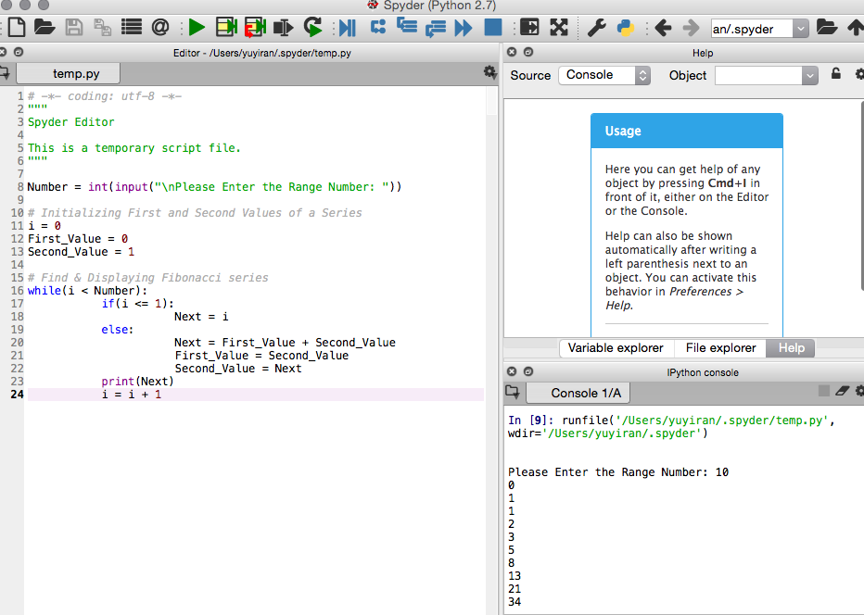

1. Using jupyter notebook

